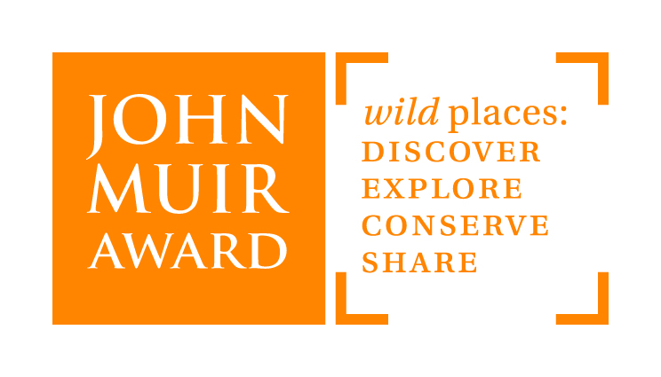
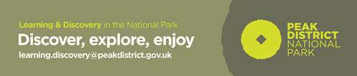
John Muir Award in the
Peak District National
Park
Training Day
The John Muir Award is an environmental Award scheme. It encourages people to enjoy, connect with, and care for the planet's wild places. This training day will show you how versatile this award is for a range of outdoor settings and the curriculum opportunities it can enrich.
Who is the course for?
Teachers, Head-teachers, classroom assistants, outdoor centre instructors and all who support learning outdoors.
What’s on offer?
This course will help you..
- find out about the John Muir Award and how it works
- gain ideas and share good practice in using the John Muir Award to support outdoor learning in your school
- get some simple ideas for taking learning out of the classroom in your own setting or wider into the Peak District National Park.
Course Venue: Moorland Discovery Centre, Longshaw Estate, Derbyshire S11 7TZ
Date: Friday 10th February
Time: 10.00am – 3.30pm
What to bring: Indoor and outdoor shoes, suitable clothing for the outdoors and a packed lunch
Cost: FREE

Interested?
For more information visit https://www.johnmuirtrust.org/john-muir-award

To book a place contact Ruth Boys, John Muir Award England Education Manager: ruth@johnmuiraward.org

